20499 -CASE STUDY PATIENT ONLINE CONSULATION WITH DOCTOR

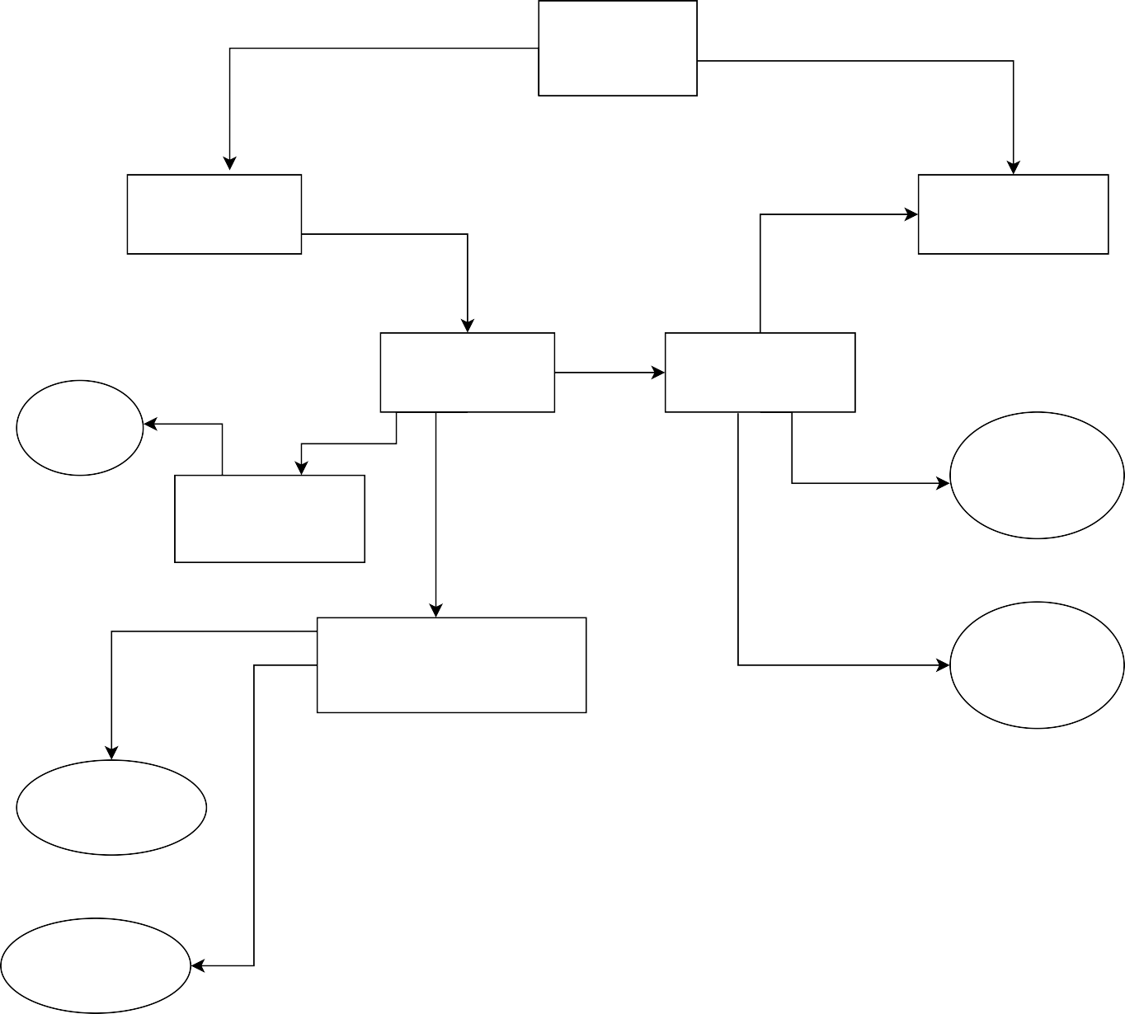

LOGIN

PATIENT DOCTOR

PATIENT ID ONLINE

AMOUNT

DOCTOR NAME

BILL ID

APPOINTMENT SPECIALIZATION

NAME

DESCRIPTO

AGE

DATE & TIME

GENDER

ADDRESS

**1: LOGIN CREDENTIALS TABLE**

|  |  |  |  |
| --- | --- | --- | --- |
| **LOGIN ID(PK)** | **PATIENT(FK)** | **DOCTOR (FK)** | **PATIENT ID(FK)** |

**2: APPOINTMENT TABLE**

|  |  |  |  |
| --- | --- | --- | --- |
| **PATIENT ID(PK)** | **APPOINTMENT** | **ONLINE (FK)** | **BILL ID(FK)** |

**3: REGISTRATION TABLE**

|  |  |  |  |  |  |  |  |
| --- | --- | --- | --- | --- | --- | --- | --- |
| **PATIENT ID(PK)** | **APPOINTMENT(FK)** | **NAME** | **AGE** | **GENDER** | **DESCRIPTO** | **ADDRESS** | **DATE &TIME** |

**4: APPOINTMENT SCHEDHULE**

|  |  |  |  |
| --- | --- | --- | --- |
| **DOCTOR (PK)** | **PATIENT ID(PK)** | **APPOINTEMNET(PK)** | **DATE AND TIME** |

**5 : BILLING TABLE**

|  |  |  |  |
| --- | --- | --- | --- |
| **PATIENT(PK)** | **BILL ID(PK)** | **AMOUNT** | **DATE AND TIME** |

**20499 -CASE STUDY PATIENT ONLINE CONSULATION WITH DOCTOR**



**LOGIN**

**PATIENT DOCTOR**

**PATIENT ID ONLINE**

**AMOUNT**

**DOCTOR NAME**

**BILL ID**

**APPOINTMENT SPECIALIZATION**

**NAME**

**DESCRIPTO**

**AGE**

**DATE & TIME**

**GENDER**

**ADDRESS**